Experiment – 8: Laplace Transform, Inverse Transform, ROC and Stability
ii) Determination of Inverse Laplace Transform for Signal Reconstruction
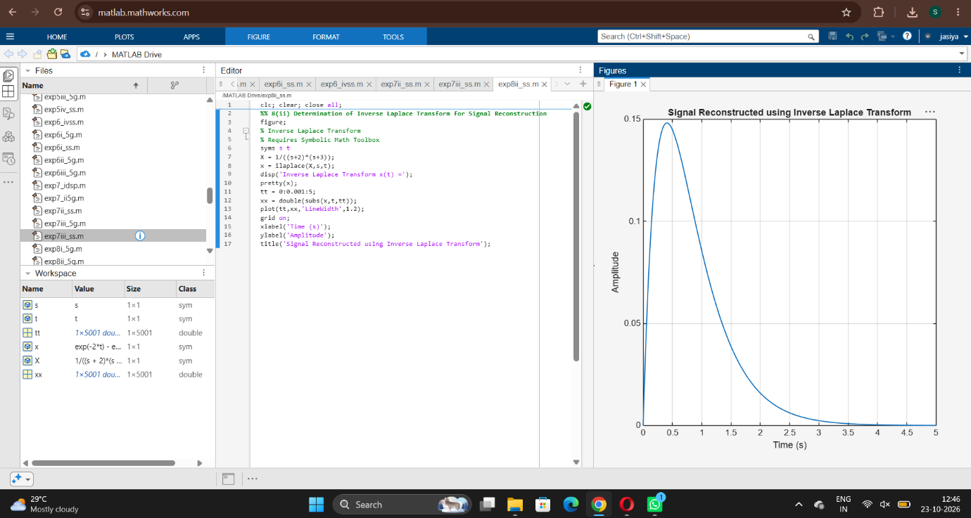
iii) To determine the Region of Convergence (ROC) of Laplace transforms and analyze its significance in characterizing continuous-time signals and systems. Expected Outcomes
